GitHub Actions + SonarQube + Docker + EKS Project
1. Create and Clone the GitHub Repository
Create an empty repository in GitHub with the name:
Github-Actions-Project
Open VS Code → Terminal → Git Bash and clone the repository:
git clone https://github.com/harathi-mutyam/Github-Actions-Project.git
2. Push Local Code to GitHub (optional here)
Open Git Bash in the project directory.
Remove the existing Git configuration:
rm -rf .git
Initialize Git:
git init
Rename the branch to main:
git branch -M main
Add the .gitignore file:
git add .gitignore
Commit the changes:
git commit -m "Add gitignore to project"
Add all project files:
git add .
Commit the project:
git commit -m "project"
Add the GitHub remote repository:
git remote add origin https://github.com/harathi-mutyam/Github-Actions-Project.git
Push the code:
git push -f origin main
3. Create the AWS Security Group
Open the AWS Console → EC2 → Security Groups.
Create a security group named:
githubaction_sg
Configure the required inbound rules:
Type | Protocol | Port | Source
SMTPS | TCP | 465 | Anywhere IPv4
Custom TCP | TCP | 587 | Anywhere IPv4
Custom TCP | TCP | 3000–11000 | Anywhere IPv4
HTTP | TCP | 80 | Anywhere IPv4
HTTPS | TCP | 443 | Anywhere IPv4
SSH | TCP | 22 | My IP
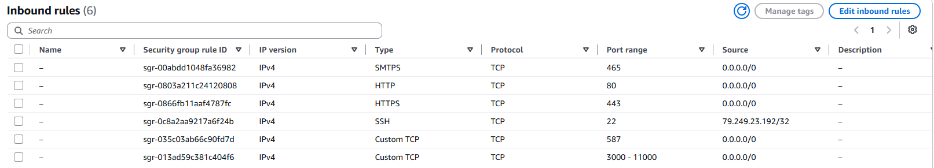
4. Create the GitHub Actions Self-Hosted Runner
Create an EC2 instance with the following configuration:
- Name: Runner
- OS: Ubuntu
- Instance type: c7i-flex.large
- Key pair: github-key
- Security Group: githubaction_sg
- Storage: 25 GB
Connect to the instance using Git Bash:
ssh -i Downloads/github-key.pem ubuntu@<public-ip-of-runner-ec2-instance>
Update the system:
sudo apt update
Set the hostname:
sudo hostnamectl set-hostname runner
/bin/bash
5. Configure the GitHub Self-Hosted Runner
Open your GitHub repository:
Actions → Runners → Self Hosted Runner New self-hosted runner → Linux
Copy the commands displayed by GitHub and execute them on the Runner EC2 instance.
For reference:
copy those commandsopen Runner gitbashpaste those commands and run itAgain go back to git hub repository in browser copy the download the latest runner package commandpaste it in Runner gitbash and run it again open in browser github respository copy the extract the installer commandpaste it in the Runner gitbash and run it
After downloading and extracting the runner package:
cd actions-runner
Check the files:
ls
If required, remove the downloaded tar file:
rm actions-runner-linux-x64-2.322.0.tar.gz
ls
For Reference:
Now Configure the Runner: open github repository in browser copy the command related to create Runner & start the Configuration experience paste it in EC2 Runner Gitbash & run it
Press Enter for Default here type: Press EnterEnterType Runner1 Provide Labels: here type self-hosted
Enter the name of work folder: Press enter key here for default

Configure the runner using the command provided by GitHub.
When prompted:
- Press Enter for the default values where appropriate.
- Enter Runner1 as the runner name.
- Enter self-hosted as the label.
- Press Enter to use the default work folder.
ls
for reference: Open github repository in browseropen same repository in duplicate browserselect settings -->actionsrunnersNow you can see Runner1 is in offline
open EC2 runner gitbash run the below command
Start the runner:
./run.sh
You should see a message similar to:
Connected to GitHub
Listening for Jobs
The runner is now connected to GitHub and ready to execute GitHub Actions jobs.
For referece: Open guthub repository in browser Refresh the pageYou can observe status changed to idle or active
6. Install Maven on the Runner
Check the cicd.yaml file in:
.github/workflows/cicd.yaml
Since the workflow uses Maven, Maven must be installed on the Runner EC2 instance.
Open one more gitbash for installation purpose
Connect to the Runner:
ssh -i Downloads/github-key.pem ubuntu@<public-ip-of-runner-ec2-instance>
sudo hostnamectl set-hostname runnerinstalationpurpose

/bin/bash
Install Maven:
sudo apt install maven -y
Go to GitHub → Actions and run the workflow again.(click on re-run jobs)
At this stage, the pipeline should proceed successfully through the compe job phase.
7. Create the SonarQube EC2 Instance
Create another EC2 instance for SonarQube.
Configuration:
- Name: SonarQube
- OS: Ubuntu
- Instance type: c7i-flex.large
- Key pair: github-key (old one)
- Security Group: githubaction_sg (old one)
- Storage: 25 GB
Connect to the SonarQube instance:
ssh -i Downloads/github-key.pem ubuntu@<public-ip-of-sonarqube-ec2-instance>
Set the hostname:
sudo hostnamectl set-hostname sonarqube
/bin/bash
Update the system:
sudo apt update

Install Docker: type
docker #Install docker through sonarqube
sudo apt install docker.io -y
Add the current user to the Docker group:
sudo usermod -aG docker $USER
Apply the group changes:
newgrp docker
Run SonarQube:
docker run -d --name sonar -p 9000:9000 sonarqube:lts-community
8. Open SonarQube
Open a browser and enter:
http://<sonarqube-ec2-public-ip>:9000
Use the default login credentials:
Username: admin
Password: admin
After login, the Change Password page will appear.
Enter:
Old Password: admin
New Password: admin123
Confirm Password: admin123
Click Update Password.
You will then be redirected to the SonarQube dashboard.
9. Generate the SonarQube Token
In SonarQube:
Administration(top navigation bar) → Security → Users
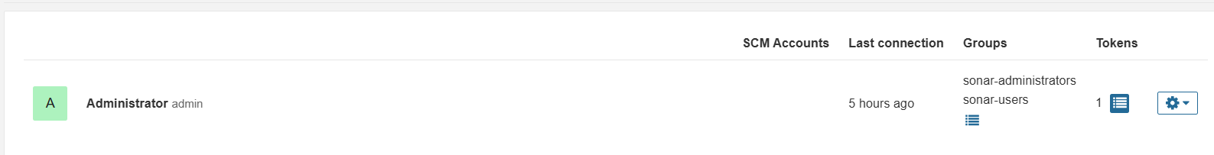
Under the token section click on this symbol .It will open this page
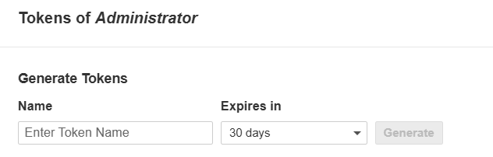
Using the above one generate a new token.
Provide a name for the token (Name : A) and click Generate.
Copy the generated token and store it securely.
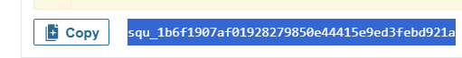
10. Add SonarQube Secrets to GitHub
Open:
Our project GitHub Repository in browser → Settings → under Security and quality Secrets and variables → Actions-select secrets tabnew repository secret button
Create a repository secret:
Name: SONAR_TOKEN (The name must be match the name used in cicd.yaml file under build_project_and_sonar_scan: job)
Value: paste the <SonarQube-token> here
The name must match the name used in cicd.yaml.
Create a repository variable:
Now select variable tab new Repository Variable

Name: SONAR_HOST_URL
Value: http://<sonarqube-ec2-public-ip>:9000
The variable name must also match the name used in cicd.yaml
11. Install Docker on the GitHub Actions Runner
If the pipeline fails during the Docker stage, install Docker on the Runner EC2 instance( for that open runnerinstalationpurpose gitbash).

Follow the official Docker installation instructions for Ubuntu.
For reference: open google in browser search docker install in ubuntuclick the official link https://docs.docker.com/engine/install/ubuntu/
copy the Set up Docker's apt repository commands from browser , paste and run in

runnerinstalationpurpose gitbash terminal

# Add Docker's official GPG key:
sudo apt update
sudo apt install ca-certificates curl
sudo install -m 0755 -d /etc/apt/keyrings
sudo curl -fsSL https://download.docker.com/linux/ubuntu/gpg -o /etc/apt/keyrings/docker.asc
sudo chmod a+r /etc/apt/keyrings/docker.asc

# Add the repository to Apt sources:
sudo tee /etc/apt/sources.list.d/docker.sources <<EOF
Types: deb
URIs: https://download.docker.com/linux/ubuntu
Suites: $(. /etc/os-release && echo "${UBUNTU_CODENAME:-$VERSION_CODENAME}")
Components: stable
Architectures: $(dpkg --print-architecture)
Signed-By: /etc/apt/keyrings/docker.asc
EOF

sudo apt update

copy Install the Docker packages commands from the official docker website run those commands in runnerinstalationpurpose gitbash terminal
sudo apt install docker-ce docker-ce-cli containerd.io docker-buildx-plugin docker-compose-plugin

After installing Docker, add the Ubuntu user to the Docker group:
sudo usermod -aG docker ubuntu
Apply the changes:
newgrp docker
for reference: close the both runner related gitbashes: runnerinstalationpurpose gitbash and runner gitbash also.
Reconnect to the Runner and start the GitHub Actions runner again:
ssh -i Downloads/github-key.pem ubuntu@<public-ip of runner ec2-instance>
sudo hostnamectl set-hostname runner

/bin/bash
ls
cd actions-runner
./run.sh
Your original notes use the official Docker Ubuntu website for installation process.
12. Configure Docker Hub
Open the cicd.yaml file and update the Docker image name with your Docker Hub username and application name.
Example:
tags: harathi2026/bankapp:latest
Create a Dcoker username and password in our github repository as secrets and variable:
Open again our project github repository page in browsersettingsunder Security and qualityselect Secrets and variablesselect Actionsselect secrets Tabnew repository secret button
Name: DOCKERHUB_TOKEN (name must be match in cicd.yaml file under build_docker_image_and_push: job)
Secret: Enter Your Docker password Click on Add secret button

select variables Tabnew repository variable button
Name: DOCKERHUB_USERNAME (name must be match in cicd.yaml file under build_docker_image_and_push: job)
Value: Enter Your Docker username Click on Add Variable button

Create the following GitHub repository secret:
DOCKERHUB_TOKEN
Store your Docker Hub password/token as the secret value.
Create the following repository variable:
DOCKERHUB_USERNAME
Store your Docker Hub username as the value.
Commit the changes and run the GitHub Actions workflow again.
For reference:

Open cicd.yaml file commit the changes or click on Actions rerun the job

13. Create the EC2 Server for EKS
Create another EC2 instance to create the EKS cluster.
Configuration:
- Name: Server
- OS: Ubuntu
- Instance type: c7i-flex.large
- Key pair: github-key
- Security Group: githubaction_sg
- Storage: 25 GB
Connect to the server: open one more gitbash terminal
ssh -i Downloads/github-key.pem ubuntu@<public-ip-of-server-ec2-instance>

Update the system:
sudo apt update
Set the hostname:
sudo hostnamectl set-hostname server
/bin/bash

14. Install unzip , AWS CLI
Install the required packages:
sudo apt update
sudo apt install unzip -y
Download AWS CLI:
curl "https://awscli.amazonaws.com/awscli-exe-linux-x86_64.zip" -o "awscliv2.zip"
Extract it:
unzip awscliv2.zip
Install AWS CLI:
sudo ./aws/install
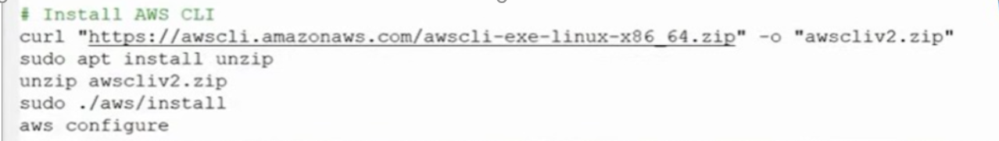
For reference:
open aws console in browsergenerate Access key and secret key for IAM user or for Root user

click on Root user (rightside top corner)security credentialsselect create a access keyselect the check box I understandselect create access key button copy or download the secret and access keys

Configure AWS:
aws configure
Provide:
AWS Access Key ID: paste <your-access-key> here
AWS Secret Access Key: paste <your-secret-key> here
Default region name: eu-north-1
Default output format: json
15. Install Terraform
Install the required packages:
sudo apt-get update && sudo apt-get install -y gnupg software-properties-common curl
Add the HashiCorp GPG key:
wget -O- https://apt.releases.hashicorp.com/gpg | \
gpg --dearmor | \
sudo tee /usr/share/keyrings/hashicorp-archive-keyring.gpg > /dev/null
Add the HashiCorp repository:
echo "deb [signed-by=/usr/share/keyrings/hashicorp-archive-keyring.gpg] \
https://apt.releases.hashicorp.com $(lsb_release -cs) main" | \
sudo tee /etc/apt/sources.list.d/hashicorp.list
Install Terraform:
sudo apt-get update && sudo apt-get install terraform
Verify the installation:
terraform --version
These are the Terraform installation steps documented in my project notes.
# 1. Install prerequisites
sudo apt-get update && sudo apt-get install -y gnupg software-properties-common curl
# 2. Add HashiCorp GPG key
wget -O- https://apt.releases.hashicorp.com/gpg | gpg --dearmor | sudo tee /usr/share/keyrings/hashicorp-archive-keyring.gpg > /dev/null
# 3. Add the repository
echo "deb [signed-by=/usr/share/keyrings/hashicorp-archive-keyring.gpg] \
https://apt.releases.hashicorp.com $(lsb_release -cs) main" | sudo tee /etc/apt/sources.list.d/hashicorp.list
# 4. Update and install
sudo apt-get update && sudo apt-get install terraform
# 5. Verify installation
terraform –version

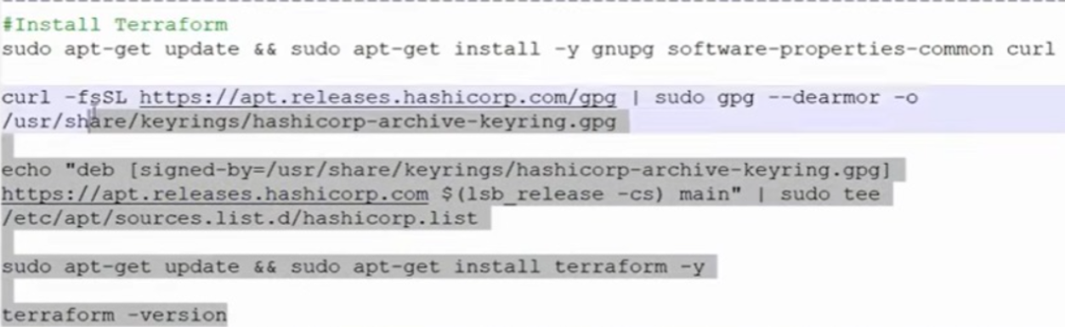

16. Clone the EKS Terraform Code
The EKS Terraform code is also stored in the GitHub Actions project repository.
Before cloning the project, open variables.tf and update the SSH key name:
variable "ssh_key_name" {
description = "The name of the SSH key pair to use for instances"
type = string
default = "github-key"
}
Replace github-key with the key pair name you are using in ec2 instances(runner,sonarqube,server instances).
Also check main.tf and update the AWS region if required:
provider "aws" {
region = "eu-north-1"
}
Clone the repository in server instance gitbash terminal:
git clone https://github.com/harathi-mutyam/Github-Actions-Project.git
Move into the project directory:
cd Github-Actions-Project
Initialize Terraform:
terraform init
Create the infrastructure:
terraform apply --auto-approve
EKS deployment producing cluster, node group, subnet, and VPC outputs.
17 resources must be created
Copy the
cluster_id = "eks-cluster"
node_group_id = "eks-cluster:eks-node-group"
subnet_ids = [
"subnet-0f697578532397c9a",
"subnet-00efb5a12c4ec3159",
]
vpc_id = "vpc-0c7afca4f7cfd81cd"
17. Install kubectl in server Gitbash terminal
Download kubectl:
curl -LO "https://dl.k8s.io/release/$(curl -L -s https://dl.k8s.io/release/stable.txt)/bin/linux/amd64/kubectl"
curl -LO "https://dl.k8s.io/release/$(curl -L -s https://dl.k8s.io/release/stable.txt)/bin/linux/amd64/kubectl.sha256"
Install it:
sudo install -o root -g root -m 0755 kubectl /usr/local/bin/kubectl
Verify:
kubectl version –client
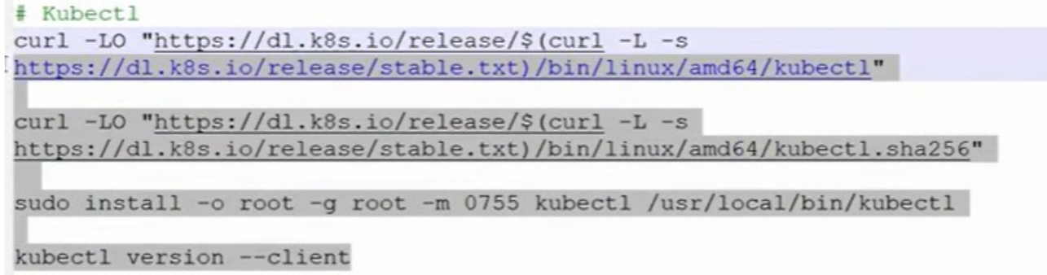
18. Configure kubectl for EKS
Update the kubeconfig:
aws eks update-kubeconfig --region eu-north-1 --name <your-eks-cluster-name>
aws eks update-kubeconfig --region eu-north-1 --name eks-cluster
Verify the worker nodes:
kubectl get nodes
ls
View the kubeconfig:
cat ~/.kube/config
The kubeconfig content is then used for the GitHub Actions deployment configuration.

19. Add EKS Secrets to GitHub
Go to:
GitHub Repository → Settings → Secrets and variables → Actions → Secrets
Create:
Name: EKS-KUBECONFIG
Value: <entire ~/.kube/config content>
Also create:
AWS_ACCESS_KEY_ID
AWS_SECRET_ACCESS_KEY
Store the corresponding AWS credentials as GitHub Actions secrets.
For reference: Save the aws access key and secret key as secrets in our project github repository
Select secrets tabselect new repository secret button
name: AWS_ACCESS_KEY_ID
secret : paste the aws access key value from aws account here save it
Select secrets tabselect new repository secret button
name: AWS_SECRET_ACCESS_KEY
secret : paste the aws secret key value from aws account here save it
Then go to Actions and run the pipeline again.
20. Install AWS CLI and kubectl on the Runner
If the GitHub Actions runner reports that AWS CLI is missing, install it on the Runner EC2 instanceopen runnerinstalationpurpose gitbash terminal.
cd actions-runner
Check AWS CLI:
aws --version
Install AWS CLI if required:
sudo apt update
sudo apt install -y unzip curl
curl "https://awscli.amazonaws.com/awscli-exe-linux-x86_64.zip" -o "awscliv2.zip"
unzip awscliv2.zip
sudo ./aws/install
Verify:
aws --version
Install kubectl:
curl -LO "https://dl.k8s.io/release/$(curl -L -s https://dl.k8s.io/release/stable.txt)/bin/linux/amd64/kubectl"
sudo install -o root -g root -m 0755 kubectl /usr/local/bin/kubectl
Verify:
kubectl version --client
Run the GitHub Actions pipeline again from the github repository.
21. Verify the Application
After the GitHub Actions pipeline completes successfully, open the Server Git Bash terminal.
Run:
kubectl get all
Find the application's DNS name from the output.
Open the DNS name in a browser and verify that the application is accessible.
Then:
- Register a new user.
- Create a username and password.
- Log in using the new credentials.
- Verify that the application is working correctly.

22. Cleanup
After verifying the application, destroy the Terraform-created resources from the Server(open server girtbash terminal):
terraform destroy --auto-approve
17 resources must be destroyed
Then:
- Terminate the remaining EC2 instances(runner instance, sonarqube instance, server instance) from the AWS Console.
- Disable and delete the AWS access key after it is no longer required.
Project Flow
GitHub Repository
↓
GitHub Actions
↓
Self-Hosted Runner
↓
Maven Build
↓
SonarQube Code Analysis
↓
Docker Build
↓
Docker Hub
↓
Terraform
↓
AWS EKS Cluster
↓
kubectl
↓
Kubernetes Application
↓
Browser
Note: Our cicd.yaml file already contains the required configuration. In a real-time project, if you need any additional actions, you can search for them in the GitHub Actions Marketplace, such as SonarQube Quality Gate Check or any other action required for your project, and add the appropriate action to the cicd.yaml file.
After making the changes, commit the updated cicd.yaml file and run the GitHub Actions pipeline again. At this stage, observe the pipeline execution. If the pipeline fails, check the error message. In our case, the Docker stage failed, so we need to troubleshoot the Docker-related issue.

